Hoàng Thanh Lâm -20194786

**Report Project 2B: Extended parser**

1: Modify file example2.kpl so that it causes the error "Invalid parameter!"

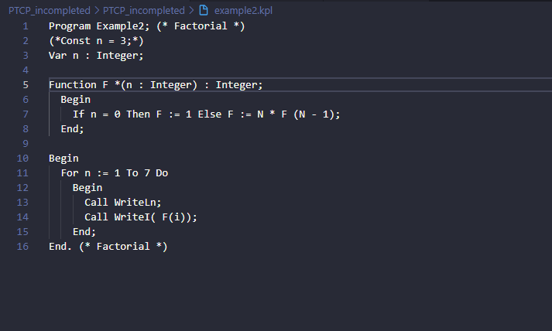

Modified code in 5th line : adding symbol * before left parenthesis.

Then the machine run this function code compileParams in parser. We specified

that lookahead->tokenType not in any case and it switch to case default and notify error .

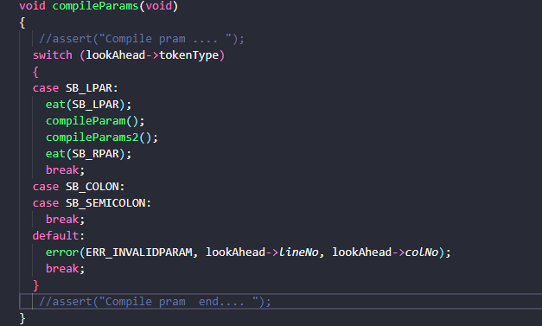

Result:

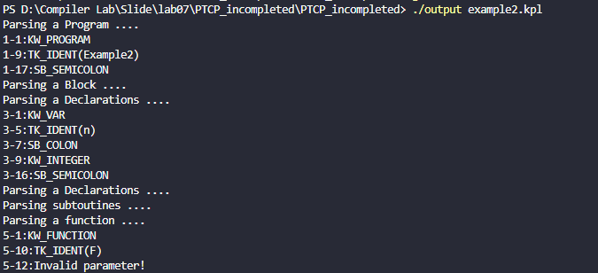

2: Suppose syntax of declarations in KPL follows the following rules

Block ::= Declarations Block2

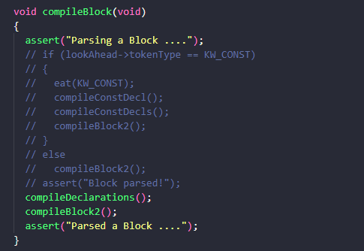

Declarations::= ConstDecls Declarations|TypeDecls Declarations VarDecls Declarations|SubDecls Declarations|?

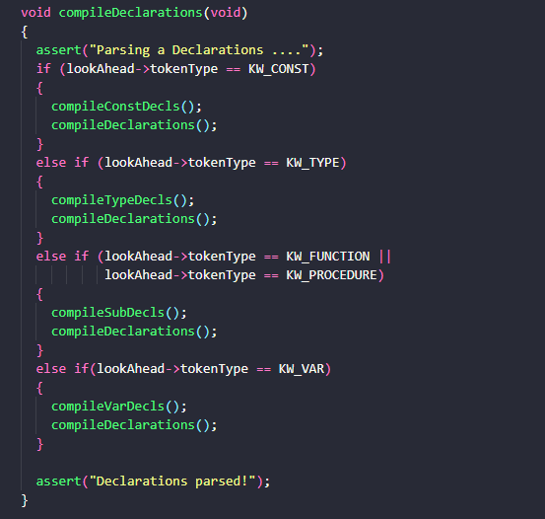

Constdecls ::= KW_CONST ConstDecl ConstDecls2

ConstDecls2::= ConstDecl ConstDecls2

ConstDecls2::= eps

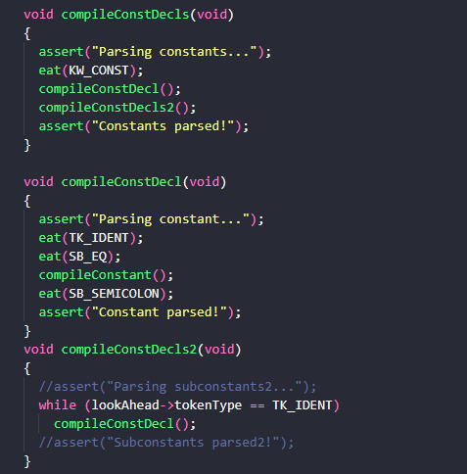

TypeDecls ::= KW_TYPE TypeDecl TypeDecls2

TypeDecls2 ::= TypeDecl TypeDecls2

TypeDecls ::= eps

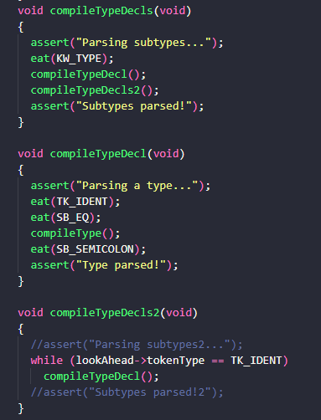

VarDecls ::= KW_VAR VarDecl VarDeclrs2

VarDecls2 ::= VarDecl VarDecls

VarDecls2 ::= eps

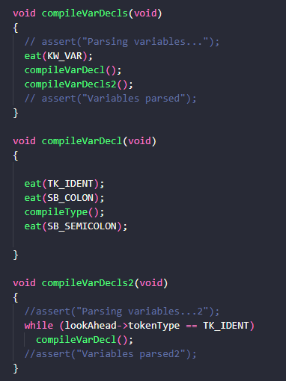

SubDecls ::= FunDecl SubDecls|ProcDecls SubDecls|?

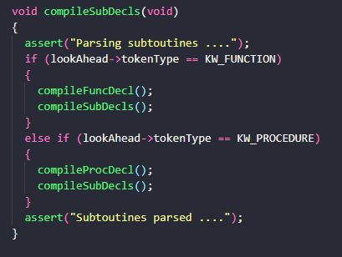

FunDecl ::= KW_FUNCTION TK_IDENT Params SB_COLON BasicType SB_SEMICOLON Block SB_SEMICOLON

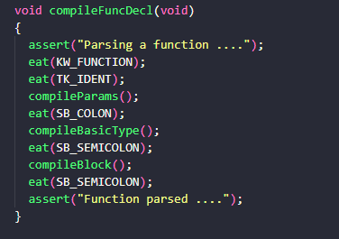

ProcDecl ::= KW_PROCEDURE TK_IDENT Params SB_SEMICOLON Block SB_SEMICOLON

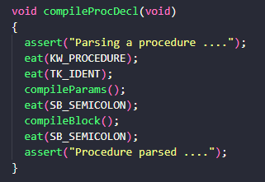

Block2 ::= KW_BEGIN Statements KW_END

